**Summary Table for Multivariable Generalized Linear Regression**

**Macro:** MULTIPLE_GENMOD

**Created Date/Author:** Oct. 26, 2012/Dana Nickleach

**Last Update Date/Person:** Dec. 17, 2013/Dana Nickleach

**Current Version:** V8

**Working Environment:** SAS 9.3 English version

**Contact**: Dr. Yuan Liu [yliu31@emory.edu](mailto:yliu31@emory.edu)

**Purpose:** To produce a summary table in a Microsoft Word Document from a multivariable generalized linear regression model using the log or logit link function with a binomial distribution; a log link with a Poisson or negative binomial distribution; or an identity link with a normal distribution. Relative risk is reported for a binomial distribution using a log link, odds ratio for a binomial distribution using a logit link; rate ratio for Poisson or negative binomial models; and slope for normal models. The modeling must be done before using this macro. The macro can also handle GEE models that were specified using the REPEATED statement.

**Notes:** The regression must be conducted using PROC GENMOD before calling this macro. Four tables must be created using ODS output when running PROC GENMOD (modelinf, nobs, type3, and estimate) using the ODS statement "ODS OUTPUT ModelInfo=modelinf NObs = nobs Type3 = type3 ParameterEstimates = estimate". Note that if a REPEATED statement was used then the estimate table needs to be created using “GEEEmpPEst = estimate”. The option TYPE3 must also be specified in the MODEL statement. Variable names must not be more than 20 characters. This macro is not set up to handle models including interaction terms and will produce incorrect results.

**Parameters:**

|  |  |  |
| --- | --- | --- |
| **Macro variable** | **Description** | **Required** |
| OUTPATH | File path for output table to be stored. | Yes |
| FNAME | File name for output table. | Yes |
| FOOTNOTE | Text of footnote to include in the table. It should be in quotes. This footnote will appear below the footnote containing the number of observations. Leave this field blank if not including an additional footnote. | No |
| TYPE3 | Set to F to suppress type III p-values from being reported in the table. The default value is T. | No |
| CONTRAST | Set to T if reporting contrast estimates from the ESTIMATE statement as well. The contrast must be specified using an ESTIMATE statement in PROC GENMOD. The EXP option should NOT be used. An ODS OUTPUT data set must be created using Estimates=contrast. The default value is F. | No |
| DEBUG | Set to T to run in debug mode. Work datasets will not be deleted in debug mode. This is useful if you are editing the code or want to further manipulate the resulting data sets. The default value is F. | No |

**Usage Example:**

**DATA** analysis;

input id os_censor Sex $ Age duration os progress $ trt $;

LABEL os = 'Overall Survival (months)'

progress = 'Progression'

trt = 'Treatment'

duration = 'Duration of Radiation';

DATALINES;

1 1 M 40 44 20 No B

2 1 F 45 46 16 Yes A

3 1 F 40 32 20 No B

4 1 F 47 32 23 No B

5 0 M 41 25 22 No B

6 1 M 54 35 13 No B

7 1 M 48 50 9 Yes A

8 1 M 36 33 12 Yes B

9 0 F 49 51 8 Yes A

10 1 M 49 52 10 Yes A

11 1 M 44 35 12 No A

12 1 M 49 50 8 Yes A

13 1 M 44 44 14 Yes A

14 1 M 50 31 10 Yes A

15 1 M 53 40 15 No B

16 0 M 52 29 20 Yes B

17 1 F 46 45 5 Yes A

18 1 F 37 44 11 Yes A

19 1 M 49 46 13 No B

20 1 M 42 31 11 No A

;

TITLE 'Table 4 Multivariate Log Model';

ODS OUTPUT ModelInfo=modelinf NObs = nobs Type3 = type3 ParameterEstimates = estimate;

PROC GENMOD DATA = analysis desc;

class Sex;

model progress = sex age/dist=bin link=log type3 wald;

RUN;

%MULTIPLE_GENMOD(

OUTPATH=C:\Documents and Settings\User\Documents\,

FNAME=Table 4 Multivariate Log Model);

TITLE;

**Summary Table Example:**

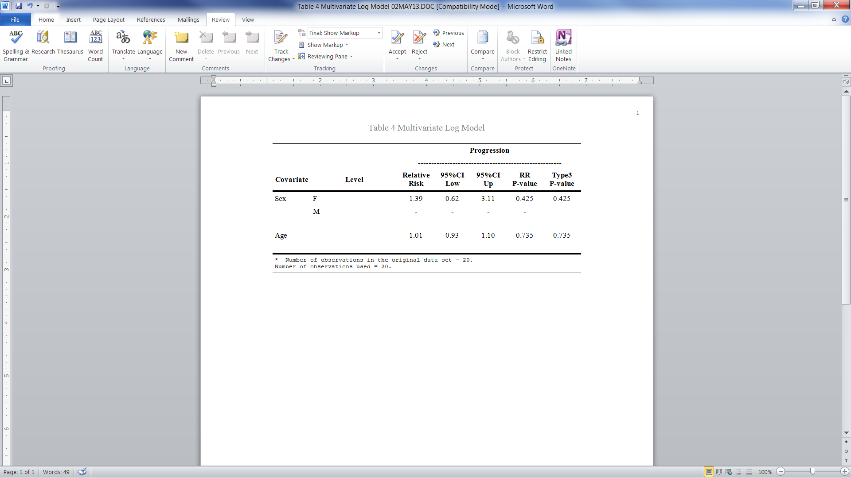

**Permission:**

Permission is hereby granted, free of charge, to any person obtaining a copy of this software and associated documentation files (the "Software"), to deal in the Software without restriction, including without limitation the rights to use, copy, modify, merge, publish, distribute, sublicense, and/or sell copies of the Software, and to permit persons to whom the Software is furnished to do so, subject to the following conditions:   
  
The above copyright notice and this permission notice shall be included in all copies or substantial portions of the Software.  
  
THE SOFTWARE IS PROVIDED "AS IS", WITHOUT WARRANTY OF ANY KIND, EXPRESS OR IMPLIED, INCLUDING BUT NOT LIMITED TO THE WARRANTIES OF MERCHANTABILITY, FITNESS FOR A PARTICULAR PURPOSE AND NONINFRINGEMENT. IN NO EVENT SHALL THE AUTHORS OR COPYRIGHT HOLDERS BE LIABLE FOR ANY CLAIM, DAMAGES OR OTHER LIABILITY, WHETHER IN AN ACTION OF CONTRACT, TORT OR OTHERWISE, ARISING FROM, OUT OF OR IN CONNECTION WITH THE SOFTWARE OR THE USE OR OTHER DEALINGS IN THE SOFTWARE.

**Log of Updates:**

|  |  |  |  |
| --- | --- | --- | --- |
| **Date** | **By** | **Description** | **Version** |
| 3/20/13 | Dana Nickleach ([dnickle@emory.edu](mailto:dnickle@emory.edu)) | Added handling of Poisson and negative binomial models, and added the outcome name to the table. | V2 |
| 3/17/13 | Dana Nickleach ([dnickle@emory.edu](mailto:dnickle@emory.edu)) | Added TYPE3 parameter. | V3 |
| 5/3/13 | Dana Nickleach ([dnickle@emory.edu](mailto:dnickle@emory.edu)) | Fixed so that it will still run without class variables and removed the DSN parameter. | V4 |
| 5/16/13 | Dana Nickleach ([dnickle@emory.edu](mailto:dnickle@emory.edu)) | Set it up to handle a normal distribution and report raw slope estimates and also work if a REPEATED statement is used. | V5 |
| 7/10/13 | Dana Nickleach ([dnickle@emory.edu](mailto:dnickle@emory.edu)) | Changed macro name from MULTIPLE_LOGRR to MULTIPLE_GENMOD. | V5 |
| 11/13/13 | Dana Nickleach ([dnickle@emory.edu](mailto:dnickle@emory.edu)) | Added capability to handle a binomial model with a logit link and added a check for unexpected link function-distribution combinations. | V6 |
| 12/11/13 | Dana Nickleach ([dnickle@emory.edu](mailto:dnickle@emory.edu)) | Modified so that the dispersion parameter from negative binomial regression is not printed in the table. | V7 |
| 12/17/13 | Dana Nickleach ([dnickle@emory.edu](mailto:dnickle@emory.edu)) | Added CONTRAST parameter. | V8 |